CISC7204 Data Science and Data Visualization

More Deaths Despite Lower Risk
A Preliminary Project Proposal on Stroke Burden in China, 2000-2021
Student Name | Li Tianhao
Student ID | MC663312
Course Code | CISC7204
Course Title | Data Science and Data Visualization
Coursework Item | Assignment 01 - Preliminary Project Proposal

Research Question
Why did China's age-standardised stroke death rate fall while the total number of stroke deaths rose between 2000 and 2021?
18 September 2026

Project Title and Research Question
Project title: More Deaths Despite Lower Risk: A Preliminary Analysis of Stroke Burden in China, 2000-2021
Region | China (mainland)
Domain category | Public health - cardiovascular epidemiology and non-communicable disease burden
Research question: Why did China's age-standardised stroke death rate fall by about 37% between 2000 and 2021, while total stroke deaths rose by about 34% over the same period?
The project tests whether the apparent contradiction is caused by two different measures of mortality. The age-standardised rate compares risk under a fixed age structure, while total deaths measure the actual burden across a population whose age structure is changing.

Project Purpose

Outcomes
I will complete an end-to-end data analysis that connects course methods to a public-health question. The proposal and notebook will demonstrate how to locate public data, clean country-year tables, join mortality and population data, calculate derived rates, create two complementary visualisations, and communicate a counter-intuitive result without overstating causality.

Skills
The project will develop skills in Python analysis with pandas and numpy, data validation, exploratory analysis, chart design with matplotlib, reproducible notebook workflow, and evidence-based written interpretation.

Knowledge
The project will develop knowledge of age-standardised versus crude rates, country-year data structures, aggregate rows, table joins, demographic transition, population ageing, and the difference between individual risk and total burden.

Datasets and Sources
The analysis uses four public datasets distributed by Our World in Data. The stroke files come from the World Health Organization Global Health Estimates 2021, and the population files come from the United Nations World Population Prospects 2024. The dataset links below satisfy the requirement for at least two available data sources.
Dataset | Indicator and coverage | Use | Source link
Stroke rate | Age-standardised death rate, both sexes; 2000-2021 | Falling-risk trend | WHO stroke data
Stroke deaths | Total deaths from stroke, both sexes; 2000-2021 | Rising death count and crude rate | WHO stroke data
Total population | Total population; filtered to 2000-2021 | Crude-rate denominator | UN population data
Population by age | Five age groups; filtered to 2000-2021 | Ageing mechanism | UN age-group data

Visualisation Justification
Chart 1 uses a dual-axis combination design: bars show total stroke deaths on the left axis and a line shows the age-standardised death rate on the right axis. Both series cover the same years, but their units differ by several orders of magnitude. A single scale would flatten the rate line and make the divergence difficult to see. The shared x-axis and separate y-axes keep both trends readable. Bars communicate total magnitude, while the line communicates continuous change over time.
Chart 2 uses a grouped bar chart to compare five age groups in 2000 and 2021. The paired bars preserve absolute population size, which is central to the explanation. The 65+ group more than doubles in size, while every younger age band shrinks. A stacked or percentage chart would remove the absolute change that makes the ageing mechanism visible. The groups are ordered from oldest to youngest so that the reader moves from the fastest-growing group to the groups that declined.

Project Tasks and Deliverables
I will complete the project in the following steps:
- Locate and document public datasets for stroke mortality and population.
- Import and inspect all four CSV files, including shape, columns, types, and sample rows.
- Remove regional and global aggregates and retain real three-letter ISO country codes.
- Check missing values and validate that the two stroke files cover the same country-years.
- Merge the stroke rate and death count on country code and year.
- Join China's population series and compute the crude death rate from scratch.
- Compare 2000 and 2021, verify the arithmetic, and produce the two required charts.
- Test whether population growth and ageing can explain the rise in total deaths.
- Prepare the final Word proposal and state the limitations of the available data.
Deliverables: an executed Python 3 notebook, two embedded charts, the source CSV files, and this 2-5 page Word proposal.

Preliminary Results and Interpretation
The preliminary analysis confirms that the two headline trends are real and measure different quantities. China's age-standardised stroke death rate fell from 187.1 to 117.5 deaths per 100,000 between 2000 and 2021, a decline of 37.2%. Over the same period, total stroke deaths rose from about 1.89 million to 2.53 million, an increase of 33.6%. The crude death rate rose by 18.9%, from 149.1 to 177.3 deaths per 100,000. The crude rate uses China's actual population and therefore captures the burden experienced by the real population.
Indicator | 2000 | 2021 | Change
Age-standardised death rate per 100,000 | 187.1 | 117.5 | -37.2%
Total stroke deaths | 1,893,445 | 2,529,663 | +33.6%
Total population | 1,269,581,174 | 1,426,437,269 | +12.4%
Crude death rate per 100,000 | 149.1 | 177.3 | +18.9%
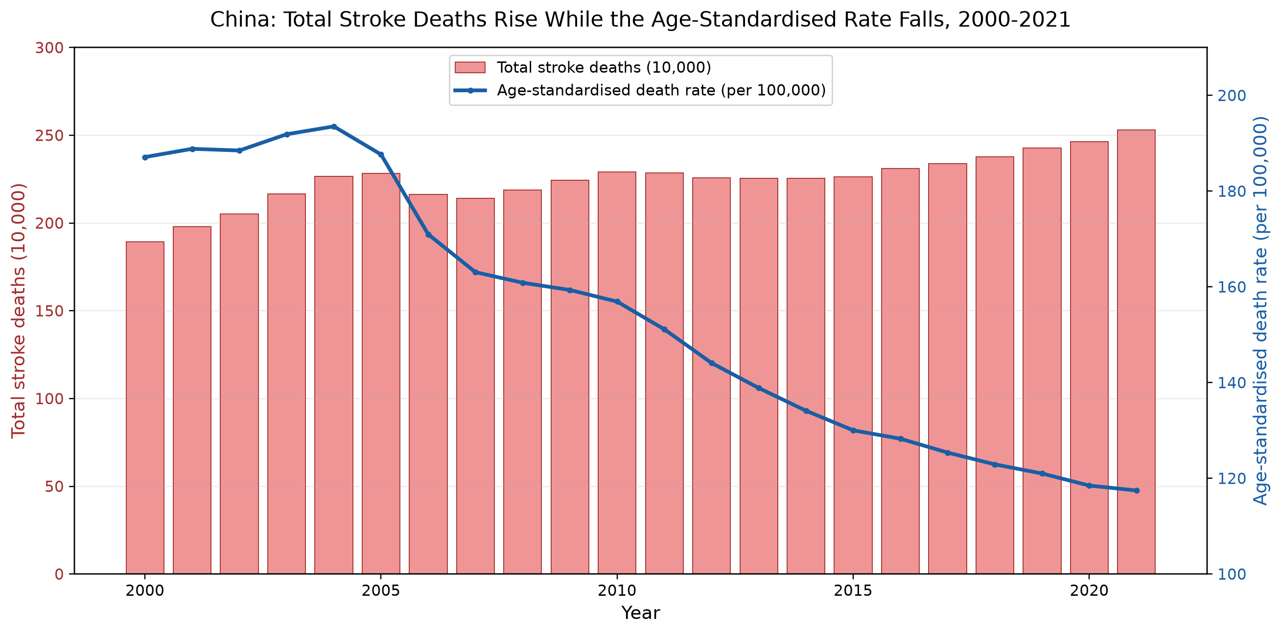
Chart 1. Total stroke deaths and the age-standardised stroke death rate in China, 2000-2021.
Chart 1 shows the divergence directly. Total deaths rise across most of the period while the age-standardised rate peaks in 2004 and then declines. The rate does not fall in every year, so the proposal should not claim a continuous annual decline. Measuring from the 2004 peak produces a larger decline of about 39.3%.
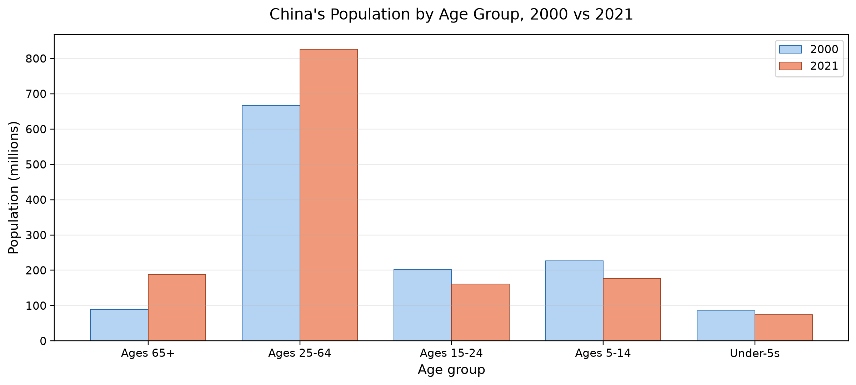
Chart 2. Population by age group in China, 2000 compared with 2021.
Chart 2 provides the main demographic mechanism. The population aged 65+ grew by 111.4%, from 89.1 million to 188.3 million. The total population grew by only 12.4%. Every younger age band shrank. Deaths rose by 33.6%, which is faster than total population growth but slower than growth of the 65+ group. This pattern is consistent with two effects operating together: an increasing number of older people and a decline in age-specific stroke mortality risk.
The analysis has an important limitation. It supports the direction of the explanation but cannot provide a formal demographic decomposition because the datasets do not include age-specific stroke death counts. A precise statement such as a specific percentage of the increase caused by ageing would require additional data.

Criteria for Success

Characteristics of Successful Deliverables
The project will be considered successful when the final analysis and visual deliverables meet the following criteria:
- Derived values, joins, and calculations pass validation checks.
- The two charts clearly address the research question and include written interpretation.
- The conclusion distinguishes association from causation and states the data limitation.

Evidence for Demonstrating Success
To demonstrate these criteria, I will use the following analysis checklist.
Check | Evidence and pass condition
Data access and filtering | All four CSV files load successfully; aggregate rows beginning with OWID_ or UN_ are excluded; only valid three-letter ISO country codes remain.
Merge integrity | The stroke-rate and death-count tables merge on Code and Year; 4,268 rows are preserved and no missing values are introduced.
Derived-rate check | crude_rate = stroke_deaths / Population x 100,000; reconstructed deaths match the reported counts within numerical tolerance.
Key results | The 2000-2021 comparison reports a 37.2% fall in the age-standardised rate, a 33.6% rise in total deaths, 12.4% population growth, and an 18.9% rise in the crude rate.
Demographic evidence | The 65+ population grows by 111.4% and is used as contextual evidence for ageing, not as a formal causal decomposition.
Visual accuracy | Both charts use the intended years and age groups, and their plotted values, axis labels, and units match the verified tables.
Interpretation and limitation | The narrative distinguishes individual risk from total burden, avoids causal overclaiming, and states that age-specific death counts are unavailable.

Collaboration Issues
This project was completed independently by me. I independently determined the research topic, identified and screened suitable datasets, selected the analytical and visualisation methods, wrote and revised all the Python code, and prepared and proofread the final documents.
Because this was an individual project, there was no division of work, no group ground rules, and no team roles such as project coordinator, project scribe, project progress tracker, or project liaison.
I was responsible for the complete project workflow. In particular, I maintained the work schedule, documented my analytical decisions, tracked progress, and reviewed both the code and final outputs before submission.

References
World Health Organization. (2024). Global Health Estimates 2021: Deaths by cause, age, sex, by country and by region, 2000-2021. Distributed by Our World in Data. https://ourworldindata.org/grapher/deaths-from-strokes-ghe
United Nations, Department of Economic and Social Affairs, Population Division. (2024). World Population Prospects 2024: Total population and population by age group. Distributed by Our World in Data. https://ourworldindata.org/grapher/population and https://ourworldindata.org/grapher/population-by-age-group

